We are working on grid1.html for this design

1)Grid Columns:

**Original design looks like this:**

#main div:nth-child(odd)

{

background: #825;

padding:20px;

}

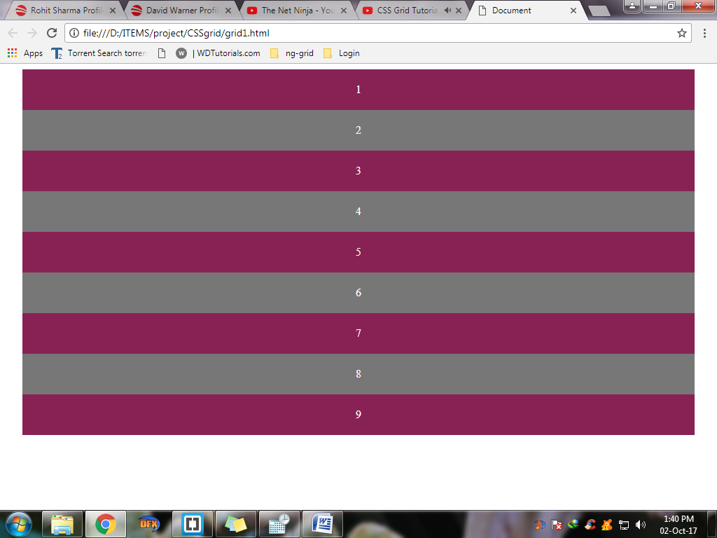

#main div:nth-child(even)

{

background: #777;

padding:20px;

}

#main

{

text-align: center;

color: white;

max-width: 960px;

margin: 0 auto

}

<div id="main">

<div>1</div>

<div>2</div>

<div>3</div>

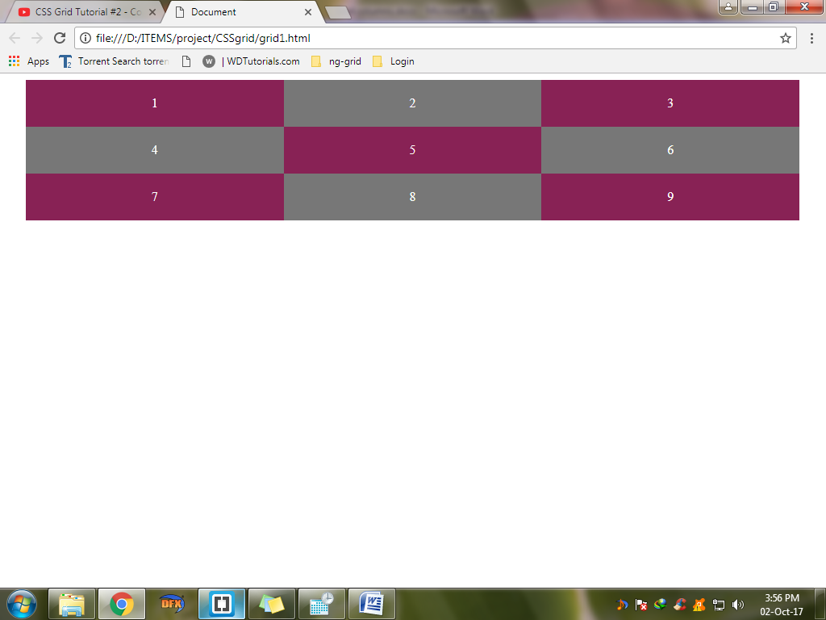 <div>4</div>

<div>5</div>

<div>6</div>

<div>7</div>

<div>8</div>

<div>9</div>

</div>

**2) Define columns**

Suppose we want 3 column grid we will use

#main {

display:grid;

**grid-template-columns:33.3% 33.3% 33.3%;**

}

If total is 100% then 3 columns will have each 100/3%

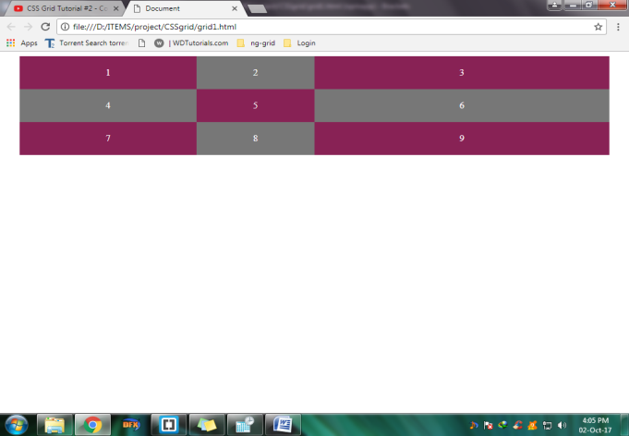

So suppose we want to make it into 3 columns but different width,last one being widest,so we can give

**grid-template-columns:30% 20% 50%;**

We can also use fractions in this case.For 3 columns we will use

**grid-template-columns: 1fr 1fr 1fr**

and get same results

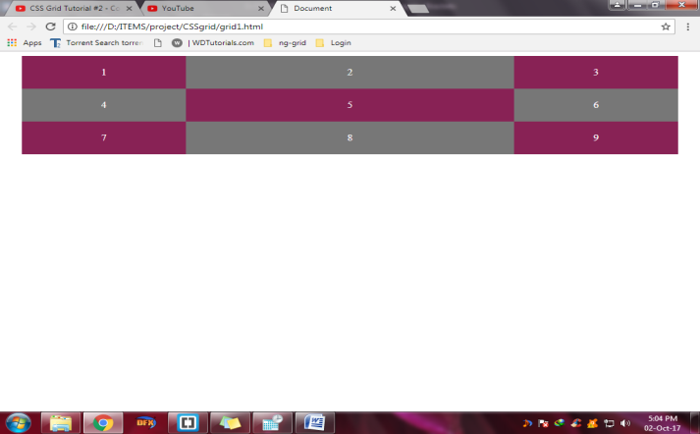

Suppose we want middle column to be double the other columns

Then

**grid-template-columns: 1fr 2fr 1fr**

We can use repeat function to show 3 columns

**grid-template-columns: repeat(3,1 fr)**

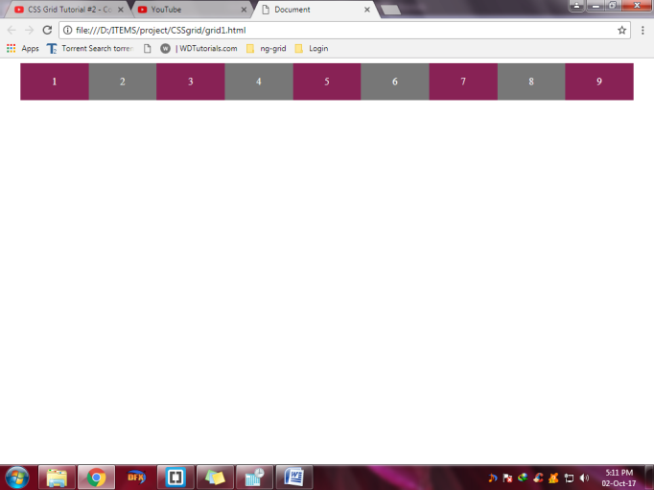this means repeat 1 fr 3 times and show 3 column grid

The reason this is cool because we can use any number of grids here say 9 column grid

**grid-template-columns: repeat(9,1 fr)** without writing 1fr 9times